Ideation Phase
Define the Problem Statements
Date: | 6 Feb 2026
Team ID: | LTVIP2026TMIDS35994
Project Name: | Househunt: finding your perfect rental home
Maximum Marks: | 2 Marks

Problem Statement (PS-1):
I am a house renter or property owner
I’m trying to find or manage rental houses efficiently
But the current rental process is mostly manual, unorganized, and time-consuming
Because property listings are scattered, communication is inefficient, and booking status is unclear
Which makes me feel confused, frustrated, and uncertain about availability, trust, and transparency
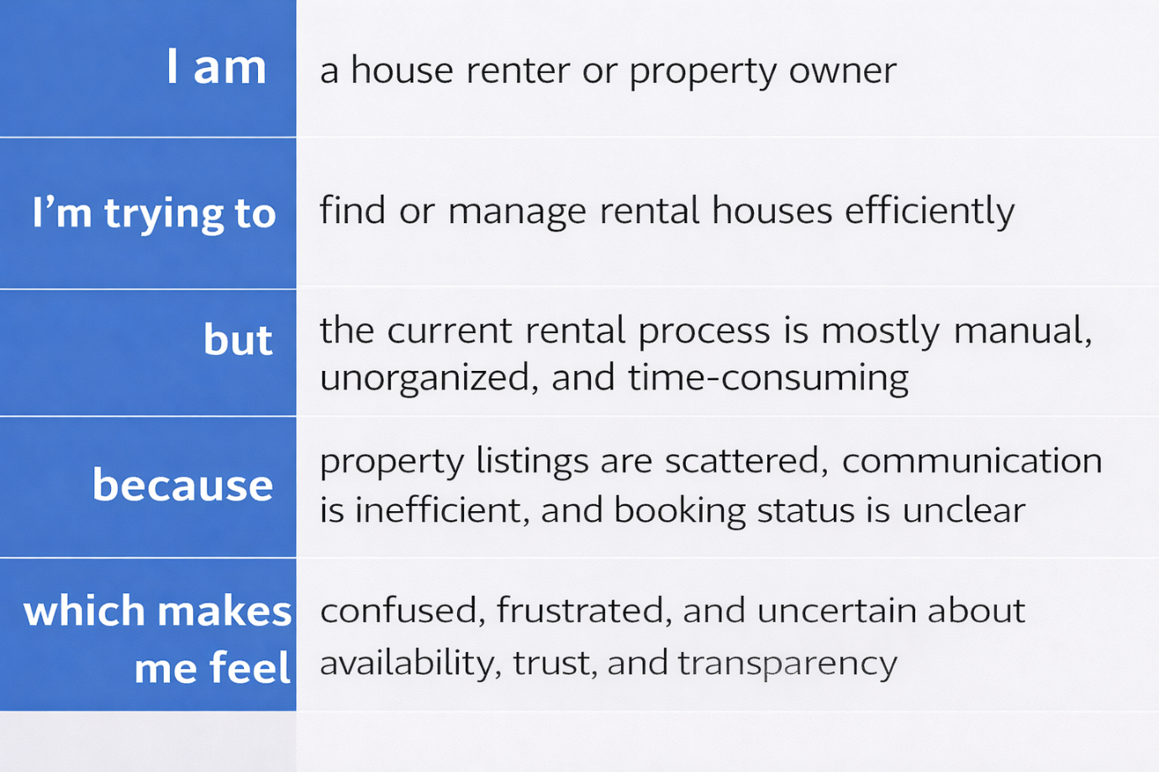

Why This Matters
Understanding these challenges helps the team design a centralized digital rental platform that connects renters, owners, and administrators in a single system.
By addressing these issues, Rent Ease aims to simplify property listing, booking, approval, and management processes. This reduces manual effort, improves transparency, enhances user experience, and ensures secure and reliable rental interactions.

